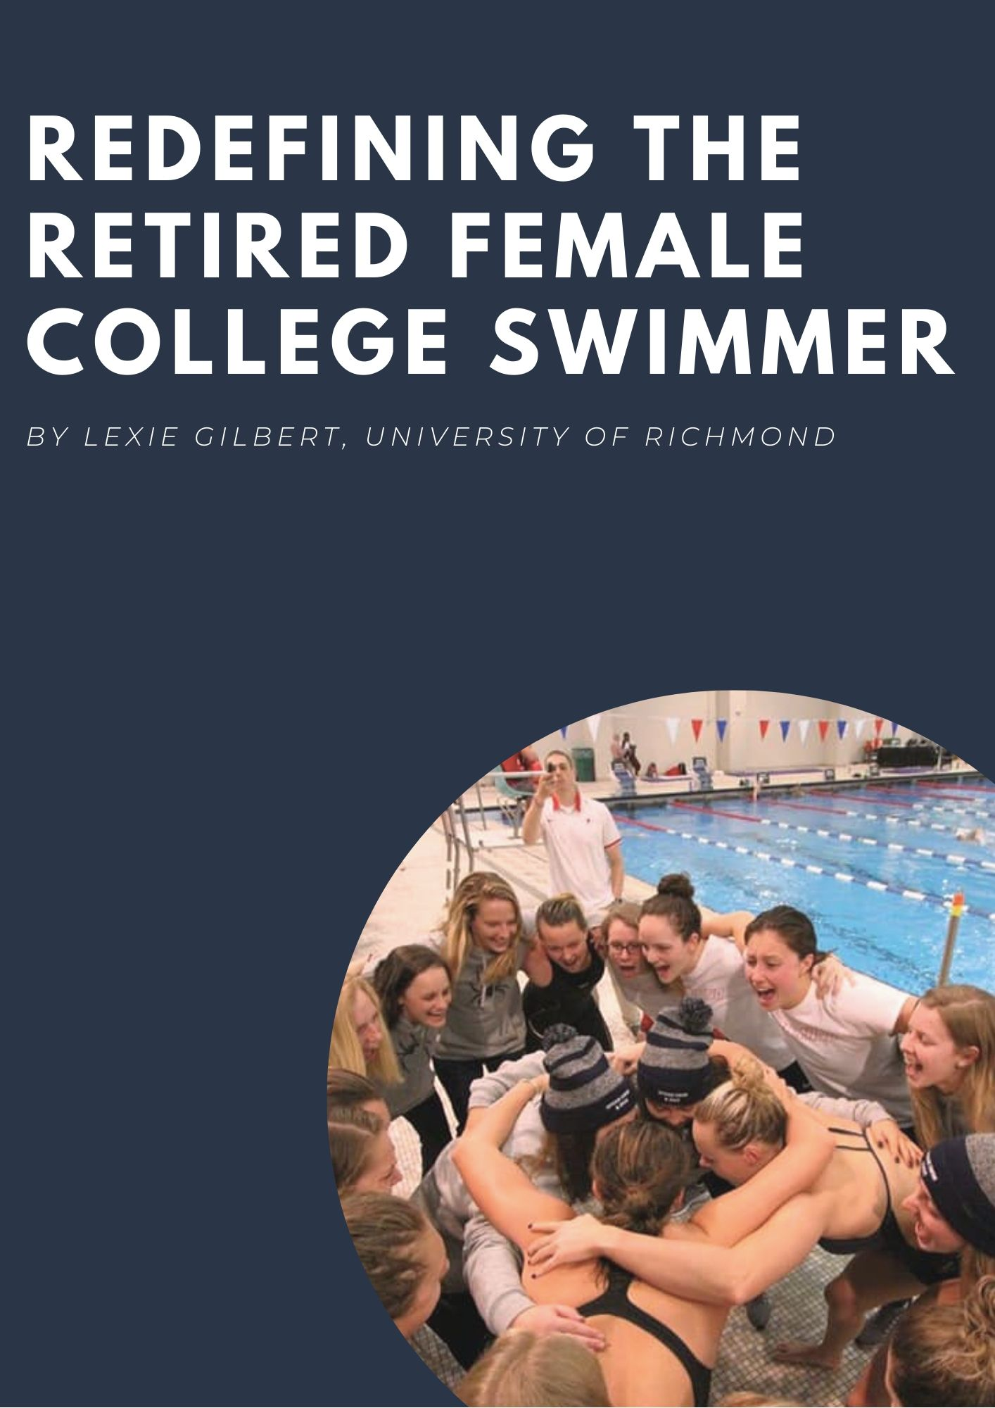

Introduction & Purpose of Study:
I began my swimming career at age five. Growing up on the Chesapeake Bay, my parents wanted to make sure I knew how to swim for safety reasons. As a result, I was placed in swim lessons and joined our neighborhood swim team. Instantly I fell in love with the sport and wanted to do it year round. When I was six, I joined the Naval Academy Aquatic Club and spent the next 13 years training there. Swimming has afforded me many ups and downs; however, my love for the sport never wavered. At a young age, I knew I wanted to swim in college. In October 2015, my dreams finally came true and I committed to a Division I program at the University of Richmond. Throughout the past four years, I have fallen more in love with the sport of swimming, than I ever thought possible. I have had the opportunity to work with some of the greatest coaches I have ever had, train with some of the best teammates I could have ever asked for, and laughed more times in the pool than I ever thought possible. In a few short weeks, I will put on my cap and goggles one last time and swim my final competitive race.
After seventeen years, I will be retiring from the sport I love. The sport that I have grown up with. The sport that has gotten me to college. The sport that has shown me what hard work, dedication, and sacrifice looks like. The sport that has given me friends for a lifetime. And the sport that has shaped me to be the young woman I am today.
For years I have identified myself as a “swimmer.” Soon it will be, “I was a swimmer,” or “I am [to be determined].” The retirement process I am about to go through is not uncommon. Upperclassmen above me had voiced their fears, excitement, and uncertainty to me. Some enjoyed it, some struggled with it. And now it is my turn to go from female college swimmer, to retired female college swimmer.
The purpose of this research paper is to shed light on the difficult transition process college athletes go through during retirement. Specifically, I will be looking at the retirement process of female college swimmers. Currently, there is very little research on the retirement process of former NCAA athletes; additionally, there is little scientific research looking explicitly at retired female college swimmers.
Through my research, I hope to gain a deeper understanding of the challenges retired female college swimmers have faced and continue to face today. With the information collected, I hope to provide insight on this mentally challenging retirement process and provide recommendations that can be used for other soon-to-be retired female college swimmers, like myself.
Background Research:
Many young athletes that fall in love with a sport desire to compete collegiately. Years of hard work, dedication, and sacrifices are made, in hopes of being recruited for college athletics. Of the thousands of high school athletes, only 7% will play in college (O’Rourke). Additionally, less than 2% will play Division I (O’Rourke). For the few that get the opportunity to fulfill their collegiate aspirations, only 2% will have a shot at playing professionally, the other 98% will retire from their sports and have to face the next chapter in their lives (NCAA).
For most of the 460,000 NCAA student-athletes (NCAA), their sport has been the defining activity in their life. In college, sport has transformed itself from an after school activity to a job. A job that requires not only 20 hours a week of physical hard work, but mental and emotional exertion as well. It alters every aspect of the college experience from who you hang out with, to what classes you can take at what times, to what you do on weekends, to the nights you forgo going out with your friends, to the foods you eat, to the time you wake up and go to bed, and much more. When a senior student-athlete faces the end of their final season, they are not simply finishing their athletic career, rather, they are losing a piece of who they are and what they know.
During this transition process and self-discovery, many student-athletes are faced with varying degrees of emotional, physical, and mental hurdles. This challenging time can cause “reductions in self-esteem, physical self-worth, and perceived physical attractiveness” (Stephan, Torregrosa, & Sanchez, 2007). This transition process is not a short and easy one. It can take many years to adjust to the new lifestyle, the new routine, and the new flexibility.
In a recent publication, in the Psychology of Sport and Exercise, Carolyn Plateau, Trent A. Petrie, and Anthony Papthomas sought to understand the “exercise attitudes and behaviours among retired female collegiate athletes” (Papathomas, Petrie, Plateau). Noting that the transition process is often a difficult one, they characterized it as “an initial period of crisis and uncertainty” (Papathomas, Petrie, Plateau). With these psychological challenges came physical challenges as well, “retirement has been linked to weight gain and reduced muscle mass… [due to] reductions in physical activity and changes in food intake” (Papathomas, Petrie, Plateau). Many former female athletes struggled with the motivation to work out after college. The challenge of “exercising independently… making decisions about the type and quantity of exercise” (Papathomas, Petrie, Plateau) proved to be challenging for the former collegiate athletes. One 24 year old retired female swimmer stated, in the study, “I do not exercise as much as I used to. I have found that without a coach it is harder to work out, push myself, and try new things” (Papathomas, Petrie, Plateau).
Plateau, Petrie, and Papthomas showed how impactful retiring from a sport can be. Not only do former female athletes face challenges on finding motivation, but many face difficulties in understanding what constitutes sufficient exercise. After four years of training 20 hours a week, many retired female athletes have trouble in “accepting a new, less intense exercise routine”(Papathomas, Petrie, Plateau). Retired female athletes “expressed frustrations at being unable to exercise as much as they would like” (Papathomas, Petrie, Plateau). Thus, former female athletes struggle with shifting their mindset of what healthy exercise looks like. Plateau, Petrie, and Papthomas suggest that these women may have an “unhealthy threshold for what they believe constitutes sufficient physical activity. Recalibrating beliefs around what is “appropriate”... appears to be an important outcome for retired athletes” (Papathomas, Petrie, Plateau).
Although a tremendous amount of research has been dedicated to college athletes during their time competing, there is a lack of scientific research regarding the post-athletics life. The NCAA acknowledges that it “has been particularly challenging… tracking the long-term effects of participating in intercollegiate athletics on former student-athletes” (NCAA Gallup). In hopes of getting a better understanding of former-athletes’ success, the NCAA worked with Gallup to conduct research on former student-athletes’ well-being, in comparison to graduated non-student athletes.
In order to understand former student athletes’ well-being, Gallup interviewed 1,670 retired collegiate athletes and 22,813 graduated non-student athletes, all graduating from the same institutions. The age range of the retired student-athletes were from age 22-71, while the non-student athletes were from the ages 21-90. Both populations had a median age of 44 (NCAA Gallup). Gallup utilized the Gallup-Purdue Index to answer questions on former student-athletes “Well-being, Workplace Engagement, and Alumni Attachment” (NCAA Gallup). Through research, Gallup confirmed that “former student-athletes are leading other college graduates in four out of five elements of well-being” (NCAA Gallup). Additionally, student-athletes have similar rates of employment, in comparison to graduated non-student athletes.
Gallup defines well-being as “the interaction and interdependence among many aspects of life” (NCAA Gallup). In order to test well-being, Gallup utilized five different elements: Purpose Well-Being, Social Well-Being, Financial Well-Being, Community Well-Being, Physical Well-Being (NCAA Gallup). The following definitions of the five elements are provided by Gallup:
- Purpose Well-Being: liking what you do each day and being motivated to achieve your goals
- Social Well-Being: Having strong and supportive relationships and love in your life
- Financial Well-Being: Effectively managing your economic life to reduce stress and increase security
- Community Well-Being: The sense of engagement you have with the areas where you live, liking where you live and feeling safe and having pride in your community
- Physical Well-Being: Having good health and enough energy to get things done on a daily basis.
Based on the individual’s response to a series of questions, Gallup would then categorize the individuals as “thriving, struggling, and/or suffering” (NCAA Gallup) according to each element. Out of the five elements tested, student-athletes were thriving more in: Purpose, Social, Community, and Physical Well-Being, in comparison to graduated non-student athletes (NCAA Gallup).
While Gallup study provided insight on the “well-being” of graduated student-athletes in comparison to graduated non-student athletes, its results were limited. For the soon-to-be graduating student athletes looking for advice and insight on what life will be like after college, the Gallup research did not create a realistic depiction of a recently retired college athlete’s life. The median age of the population studied was 44 (NCAA Gallup). At this age, there is a large discrepancy between a freshly graduated 21-22 year old and an established 44 year old. Thus Gallup failed to portray a realistic and relatable understanding of what life is like for these recently retired athletes. Additionally, Gallup’s notion of “well-being” is limited. While the five elements of well-being encompass a broad range of variables, they fail to find in-depth understanding of them.
Research Methods
In order to gain a deeper understanding of the transition process retired female college swimmers endure, qualitative and quantitative research was conducted. Through these methods of research, common themes were discovered in the initial qualitative study and then further analyzed in the quantitative study.
An initial qualitative study was conducted in order to identify common themes and trends that retired female college swimmers experience. The qualitative study was conducted via Google Forms. The survey was sent out to an initial sample group of ten individuals. Nine respondents completed the survey. The various respondents were former Division I swimmers. The respondents were asked a series of 8 open-ended questions. These questions addressed overarching themes such as, number of years swum, perspective on senior year life without swimming, challenges faced during the transition process, current athletic endeavors (if any), life lessons taught, and current relationship with swimming. The responses collected were analyzed and used to determine which themes would be focused on for further research.
Once analyzed, a quantitative survey was created, via Qualtrics. The quantitative study was conducted over a two week period in March of 2020. It consisted of 27 questions, covering topics such as general demographics, attitudes towards senior year spring semester, current exercise habits and attitudes, career, and relationship with swimming. The survey was sent out to college swim coaches across various conferences, including the A10 and CAA. Additional surveys were passed out via word of mouth. The following information is given in order to provide better understanding of the type of respondents who filled out the survey.
Respondent Profile
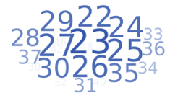
There were approximately 109 respondents for the quantitative survey. The individuals selected for the survey were retired female college swimmers. Each respondent completed four years of collegiate swimming. The average age of the respondents was 28 years old (See Appendix).
Out of the 109 respondents that took the survey, on average, respondents swam for a total of 15 years. Years swum ranged from approximately 6-30 years of swimming. Ninety percent of respondents have swum between 8-22 years.
*Please note that the average age is significantly less than the average age of the NCAA Gallup study conducted (avg. age 44).
In order to ensure that the survey encompassed all NCAA Female Swimming Divisions, all DI, DII, and DIII female swim teams were allowed to take the survey. Out of the 109 respondents, 98% of respondents attended DI swim programs and only 2% attended DIII swim programs. Approximately 21 collegiate schools were represented across the respondents. There was significant contribution from schools in the Atlantic 10 Conference (A10) and Colonial Athletic Association (CAA).
In addition, in order to understand a broader picture of what life is like post-graduation, the number of years post-graduation, for responses varied. Approximately 46% of respondents had graduated within the last four years, 35% of respondents had graduated within the last 5-10 years, and 19% of respondents had graduation 11-15 years ago (See Appendix).
Results
As stated previously, very little information is available regarding the transition process collegiate athletes go through from active college athlete to retired athlete. There is minimal information regarding the specifics of retired female college swimmers. With these points in mind, it was interesting to see the strong interest coaches and swimmers had about this topic. The qualitative and quantitative study received over a 60% response rate. Multiple coaches asked if they could have a report of the findings for themselves and for the current swimmers and alumni. Through the results below, I hope to share the attitudes, challenges, and advice of former college swimmers for the future ones to come.
Identity Loss:
Throughout the qualitative and quantitative study, the notion of an “identity loss” during retirement was heavily prevalent. Respondents felt as though they had to rediscover themselves and who they were without the sport of swimming, after spanning careers that on average, lasted over a decade long. One respondent noted the difficulty of losing her identity, stating, “Being a collegiate swimmer is a huge part of your identity” and it is “something I realized until after the fact.” Another respondent noted how “[She] had suddenly lost [her] identity” and without practice, she no longer had “as much in common with the group of people that [she] was used to spending the majority of [her] time with.” While personal identity crises were apparent in many of the respondents, the notion of a social identity crisis also surfaced. Respondents recognized that without the structured schedule swimming provided them their day-to-day and social lives were greatly shifted.
The hypothesis prior to the research conducted was that female retired swimmers would have greatly struggled the loss of swimming in their lives. This hypothesis proved to be partially correct. According to the research, approximately half of respondents said they “struggled” to cope with the loss of swimming in their lives. Out of scale between 1-5, one meaning strongly disagree and five meaning strongly agree, the mean for the statement, “I struggled with coping the loss of swimming in my life” was 2.91. Some swimmers struggled with the loss, while others did not. Research results showed that for the statement, “I was happy to be done with swimming” the average response had a score of 3.56. Eighty respondents said they “strongly agreed” with the statement “I was happy to be done with swimming.” In the qualitative survey, the respondents were able to elaborate further on these findings. Two different respondents noted the initial freedom of retirement, stating “initially it was quite freeing” and after completing “the hardest training and competitive schedule I’ve ever gone through, senior spring was a much needed break.” While some enjoyed the freedom retirement gave them, other respondents felt differently stating, “the first year after swimming ended was challenging.” She later went on to say, “I had anticipated feeling only joy and excitement once swimming was over… I was surprised at how difficult it was to navigate through that first year.”
Senior Year Spring Attitudes:
It was apparent in the study, that the initial months post retirement were most difficult for many of the retired female swimmers. While the senior year spring semester was overwhelmingly enjoyed by the respondents, the average score for the statement “I enjoyed my senior year spring semester without swim practice” equated to a 1.92, meaning “A Lot.” However, there were still some challenges. One respondent noted how her senior year spring was a “constant battle to navigate a new lifestyle” however, her “best memories were made [her] senior spring due to the lack of stress [she] had in regards to practice and getting to bed early.” For most of our respondents, senior year spring was dedicated to living the life of a “normal college student” for the last two months of their college career.
With their new found freedom in their final months of college, the respondents were asked questions regarding what they did with their free time. Thirty-three percent of respondents said they dedicated more time to their friends and meeting new people. One respondent noted, she “tried to spend a lot of time with [her] fellow graduating seniors.” Another respondent commented on the bitter sweetness of retiring, stating, she met “some new friends during this period” however, it was difficult to watch “the team continue with their normal routine.” Additionally, 21% of respondents said they spent more time going out. One respondent noted how in “those few months, [she] made up for all the times that [she] couldn’t go to concerts, on trips, etc. due to practice/ meet conflicts.”
While many of the respondents discussed their enhanced social life, a motivation and concentration on school work and finding a job after college was heavily prevalent. Twenty-three percent of respondents said they focused more time on their coursework. Spring semester affords an opportunity for the respondents to “pour [their] whole self into [their] studies and classes… as opposed to splitting time between the pool and classroom.” Others emphasized time spent on “figuring out post grad plans.” Additional activities enjoyed during the spring semester included: the continuance of swimming, volunteering, focus on self, finding new hobbies, sleeping, and new forms of exercising.
Spring Semester Exercise:
To get a better understanding of the spring semester exercise habits, respondents were asked what forms of exercise they participated in. Additionally, respondents were asked if they continued to swim during their spring semester, approximately 83% of respondents stated that they did not; while 17% stated that they did continue to swim. It is important to consider that individuals who did continue to swim during their spring semester, may have qualified for Olympic Trials during an Olympic Year, thus would’ve had to have kept training. For the majority who did not continue to swim, approximately 82% percent participated in other forms of exercise. Sentiments regarding new exercise routines varied. One respondent noted how she spent her time “practicing more yoga, went to workout classes with friends and picked up running.” Another respondent mentioned how she “struggled to figure out what type of workouts would be best to do on [her] own.” For many of the respondents, running and spinning were the most common type of exercise. As former collegiate athletes who trained their cardiovascular system immensely, it was not a surprise to see that the respondents pursued another cardiovascular focused exercise. Additional popular types of exercises included: lifting, gym classes, and High Intensity Interval Training.

Current Exercise Habits:
Respondents were then asked what their current exercise routine looked like. The original hypothesis stated that respondents would not have established structured exercise routine during their spring semester; however, post college would begin a more structured exercise regimen. Approximately 95% of respondents had a current interest in exercise. It is important to note that only 47% had a structured exercise schedule, 32% had a somewhat structured schedule, and 21% had no structured schedule. Repeatedly respondents commented on the difficulty of schedule. One stated “the hardest thing to let go [during retirement] is the structure in your schedule and the accountability the sport, your coaches, and teammates instill in you.” She later described, its “very difficult to make and stick to a consistent workout regimen.” Another commented on the difficulty of finding exercise that was actually meaningful to her. She stated it was challenging “finding something I enjoyed doing that had a similar intensity level of what I would get during a practice” and finding an exercise that gave a feeling of “accomplishment.”
The respondents were asked to discuss their personal reasons behind exercise. Fifty-two percent of respondents stated they “Enjoy Exercise” a great deal. Only 1% of respondents stated they did not “Enjoy Exercise.” The following two statements the respondents answered discussed sentiments towards their struggle to exercise. The hypothesis for the statements: “I struggle to exercise on my own without a coach” and “I struggle to understand what “enough exercise” looks like,” expected respondents to struggle a great deal without the presence of a coach and understanding what sufficient exercise looks like. As stated in the Plateau, Petrie, and Papthomas study, the prediction was that respondents would struggle with lack of motivation for exercise or they would be over exercising in unhealthy ways. These statements had a large variance to the answers. Approximately, 16% struggle a great deal without a coach, 20% struggle a lot, 30% struggle a moderate amount, 20% struggle a little and 14% do not struggle at all. The largest percentage for “I struggle to understand what “enough exercise” looks like” was 29% a moderate amount. Approximately 20% struggle a great deal to understand what enough exercise looks like. One respondent confirmed this notion of struggle when she stated, “I did not really know what to do in a gym without anyone instructing me.” A major concern regarding the former athletes was their frequency of exercise, 44% of respondents chose “none at all” for the statement “I often over-exercise.” Only 10% of respondents chose “a great deal.”
Respondents were also asked if they continue to swim today. Fifty-seven percent of respondents stated that they do not swim today, while 43% of respondents stated that they do. For the individuals that do swim currently, only 8% swim daily, 40% swim weekly, 40% swim monthly, and 12% swim yearly.
Respondents were asked to address if they have continued to pursue other forms of exercise, outside of swimming. Twenty-eight percent of respondents stated that they do, while 72% stated that they do not. Forms of exercise included adult recreation leagues, running, triathlons, fitness classes, yoga, CrossFit, and others. The participation of these activities were heavily concentrated in daily and weekly frequencies. Approximately 50% of respondents participated in these activities daily and 43% participated weekly. Respondents were asked why they chose to exercise. Motivations for exercise consisted of: for fun, for fitness, for competitive purpose, for social reasons, and for mental-health.
Current Nutrition:
Prior to this research, a major concern regarding the health of the former collegiate swimmers entailed nutrition. The quantitative survey did not explicitly address nutrition; however several respondents in the qualitative study personally addressed these concerns. Respondents noted how during the period of transition a lot changes occur, amongst these changes were diet and nutrition. On average, in a two-hour moderately difficult practice, swimmers can burn 1,200 calories (Brigette Peterson). Due to such large caloric expenditures, swimmers are encouraged to eat upwards to 3,000-5,000 calories a day. After years of club swimming and four years of collegiate swimming, it is difficult to reduce the amount of food intake you once consumed. Several respondents mentioned how either they were struggling with downsizing their portions or they were cutting back so much food that they failed to get proper sustenance. One respondent stated, “I was overeating while other times I was under-eating.” Another mentioned how shifting her mindset around food was difficult, “I still carry that thought process, thinking that I can eat whatever I want.” She later went on to discuss, “Understanding how to fuel my body without swimming continues to be a struggle.”
Current Employment:
In addition to understanding the respondents’ physical well-being, the respondents were asked questions regarding their current employment and how, if at all, swimming helped prepare them for their professional working career. Ninety-three percent of the respondents are currently employed, only 7% of respondents are unemployed.
Respondents were asked to shed light on how swimming has impacted their career. One hundred percent of respondents agreed that they have been able to apply the lessons learned in swimming to their career. Values such as organization, drive, results-oriented, team-focused, competitive, dedication, strong time-management, and others, were common values listed. Ninety-five percent of respondents agreed that swimming has helped their career in swimming. One respondent stated, “My current boss has said 70% of the reason he hired me was because of my athletic background.” While another stated, swimming taught her “core fundamentals [that] have helped to set [herself] apart from other co-workers.”
Current Relationship With Swimming:
The last topic the research addressed was the respondent’s relationship with swimming. After completing careers that on average spanned longer than a decade, and completing four years of intense collegiate swimming, the research wanted to understand how the respondents felt about swimming. For the most part, the respondents left swimming on good terms. Approximately 33% of respondents have an extremely good relationship with swimming, 39% have a somewhat good relationship, 21% have a neither good nor bad relationship with swimming, 6% have a somewhat bad relationship, and only 1% has an extremely bad relationship with swimming. Sentiments towards swimming varied. Several noted that they continue to love the sport; however, they currently have no interest in participating in it. Some stated that it is complicated and others stated they have no interest in it. One respondent stated, “I will always love swimming” and although she doesn’t swim often, “whenever [she] is able to put on [her] cap and goggles, it feels like home.” Another commented on missing the feeling of being “really good at something and the feeling of competing.” On the contrary, one respondent noted she has not been in a pool and has “not had any interest in swimming for exercise.”
There is an abundance of emotions surrounding the transition process, the challenges and triumphs, the feeling of loss, and the start of a new chapter. While these respondents enjoyed incredible careers, ones that helped them make lifelong friendships, learn valuable skills, and more, there was a sense of pride in completing such long lasting careers. When asked if the respondents missed swimming, 63% stated they do.
Key Takeaway
While the respondents no longer feel that they can identify themselves as “a swimmer,” they can, however, identify themselves as “athletes.” It is important to understand that just because your collegiate career ends, doesn’t mean you automatically lose all the components in your life that made you a successful swimmer. Values, skills, talents, and traits that have been developed and ingrained in you throughout your swimming career are not lost because your career ends. Fundamentally you are an athlete. Our respondents clearly showed these sentiments in our research. Many found ways to continue utilizing the values, discipline, drive, and motivation swimming once gave them in their current endeavors.
Recommendations
To begin the process of a successful transition, it is important to focus on three different areas: developing a fundamental and honest understanding of the retirement process, understanding your personal self, and initiating conversations. The following recommendations have been created in collaboration with Bridget Ruiz, an executive performance coach from the Team Performance Institute, who works with retiring Team USA athletes and military veterans.
Developing a Fundamental and Honest Understanding of Retirement: When starting and navigating the retirement process, it is important to understand three things. Firstly, understand that this is a real life transition process. And Secondly, it is a gradual process. The retirement from the sport of swimming, is an adjustment to life. Your routine, your friendships, your personal expectations for yourself, and many other elements shift. However, this shift is not abrupt. It is a gradual change. Yes, you may have finished your last competitive race, but that doesn’t mean you are no longer an athlete.
Thirdly, adjust the analogy we use for retirement. Oftentimes, people say we are “turning a chapter” or “starting a new chapter in our lives.” This analogy is wrong and it is limiting. It suggests that we leave behind the person we once were in one chapter of our lives and transform into a new character. That is simply not true. The athlete we have been throughout our years of swimming, will continue to be present in ourselves for years to come. As Ruiz suggested, use the analogy of a “stew pot.” For most of our lives, “our stew has been composed of the majority of swimming.” Now, we are adding new hobbies, new interests, new experiences, and much more to our “stew.” While our stew may now be composed of many different things, it still has swimming as a key ingredient.
Understanding Your Personal Self: During this process, it is important to shift your mindset from the demanding expectations collegiate athletics places on oneself. Throughout the years of swimming, we are often driven by external validators. These validators can be our coaches, teammates, championships, titles, time standards, and much more. Additionally, we utilize high external benchmarks to determine our success. We use these validators to push ourselves, to be the best teammate and athlete we can be. It is easy to find ourselves motivated by external validators, rather than our internal validators. To overcome this, it is important to shift this mindset and identify “who is the real me?” amongst all of those external validators. What were the internal motivators that truly drove you in the sport of swimming and how can you carry them on in your life. Or even, do you want to carry those internal motivators on in your life? It is so important to pull back all the layers of the sport of swimming and understand what truly fueled you intrinsically.
Part of understanding what fuels you intrinsically is understanding your values. Ruiz defines values for her athletes as, “things that are inherent to you, they keep you feeling fulfilled.” They are your personal needs that must be met in order to fulfill you. Values are separate from strengths, skills, and talents. These things you bring to others. During the process of retirement, it’s important to separate your values from your skillset. Seek things in life that feed your values. Whether it be exercise, hobbies, or a range of other activities, it's important that they are focused on fulfilling your values. With this process of understanding your values, it is necessary to periodically self-assess. Periodic checkpoints can provide opportunities for you to evaluate the activities you are doing and determine if they fulfill your values and intrinsic needs.
Initiating Conversations: In order to make this process easier, it is important for dialogues take place. There is a recurring stigma around the retirement process. I remember as an underclassmen watching the seniors agonize over the retirement process. Some were excited and others were not. It is necessary to have the conversations of retirement before the senior year. The stigma of retirement needs to shift from fear or uncertainty to opportunity. This can happen in proactive conversations. These conversations should be positive and supportive. They should encourage the idea that our emotions are “fluid.” It is okay to love swimming, but also be ready to retire. During these conversations, it is important to maintain a positive environment, but also keeping an open mind for doubt and addressing all the mixed emotions about the process.
Personal Takeaway:
When I first began this project, I was in the final weeks of my swimming career. As a senior, I had many mixed emotions. I was focused on enjoying my final weeks of my career; however, I was also looking forward to a future without intense training. As an individual who thrives in a structured, disciplined, and hard working environment, I was nervous about my transition to retirement and the feeling of a “lost identity.” I was concerned about the lack of structure my life would have without the sport of swimming.
Since completing my research, I have found a sense of peace. All 109 respondents provided me the guidance I needed to go forth and succeed in life without swimming. Their responses revealed to me that although I may be called a “swammer” now, I will always be an athlete. And no one can take that away from me.

References
O'Rourke, Patrick. “Odds of Playing a College Sport From High School.” Scholarship Stats, 2017, www.scholarshipstats.com/varsityodds.html.
“NCAA Recruiting Facts.” NCAA, 2018, https://www.ncaa.org/sites/default/files/Recruiting%20Fact%20Sheet%20WEB.pdf.
Stephan, Y., Torregrosa, M., Sanchez, X. (2007). “The Body Matters: Psychophysical Impact of Retiring From Elite Sport.” Psychology of Sport and Exercise, 8 (1), 73-83.
Papathomas, A., Petrie, T. A., & Plateau, C. R. (2018). Changes in body image perceptions upon leaving elite sport: The retired female athlete paradox. Sport, Exercise, and Performance Psychology, 7(1), 30–45.
Understanding Life Outcomes of Former NCAA Student-Athletes. Washington, Dc.: The Gallup Organization, 2016.

Research Appendix
Redefining the Retired Female College Swimmer
Conducted by: Lexie Gilbert
Q5 - How many years ago did you graduate from college?
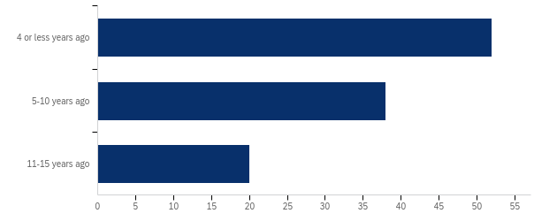

# | Field | Minimum | Maximum | Mean | Std Deviation | Variance | Count
1 | How many years ago did you graduate from college? | 1.00 | 3.00 | 1.71 | 0.75 | 0.57 | 110

# | Answer | % | Count
1 | 4 or less years ago | 47.27% | 52
2 | 5-10 years ago | 34.55% | 38
3 | 11-15 years ago | 18.18% | 20
 | Total | 100% | 110

Q7 - When thinking about the transition process from "Swimmer" to "Retired Swimmer," please rate how much you would agree or disagree with the following statements.
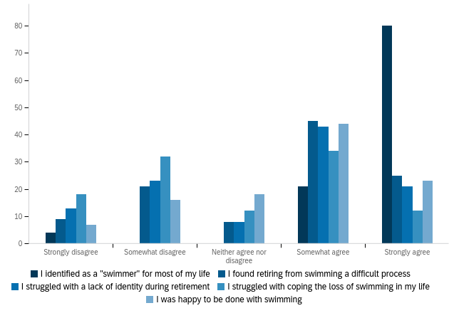

# | Field | Minimum | Maximum | Mean | Std Deviation | Variance | Count
1 | I identified as a “Swimmer” for most of my life | 1.00 | 5.00 | 4.65 | 0.83 | 0.69 | 105
2 | I found retiring from swimming a difficult process | 1.00 | 5.00 | 3.52 | 1.27 | 1.60 | 108
3 | I struggled with a lack of identity during retirement | 1.00 | 5.00 | 3.33 | 1.33 | 1.76 | 108
4 | I struggled with coping the loss of swimming in my life | 1.00 | 5.00 | 2.91 | 1.31 | 1.71 | 108
5 | I was happy to be done with swimming | 1.00 | 5.00 | 3.56 | 1.17 | 1.36 | 108

# | Question | Strongly disagree |  | Somewhat disagree |  | Neither agree nor disagree |  | Somewhat agree |  | Strongly agree |  | Total
1 | I identified as a "swimmer" for most of my life | 3.81% | 4 | 0.00% | 0 | 0.00% | 0 | 20.00% | 21 | 76.19% | 80 | 105
2 | I found retiring from swimming a difficult process | 8.33% | 9 | 19.44% | 21 | 7.41% | 8 | 41.67% | 45 | 23.15% | 25 | 108
3 | I struggled with a lack of identity during retirement | 12.04% | 13 | 21.30% | 23 | 7.41% | 8 | 39.81% | 43 | 19.44% | 21 | 108
4 | I struggled with coping the loss of swimming in my life | 16.67% | 18 | 29.63% | 32 | 11.11% | 12 | 31.48% | 34 | 11.11% | 12 | 108
5 | I was happy to be done with swimming | 6.48% | 7 | 14.81% | 16 | 16.67% | 18 | 40.74% | 44 | 21.30% | 23 | 108

Q9 - When thinking about your Senior year Spring Semester, please rate the following statements
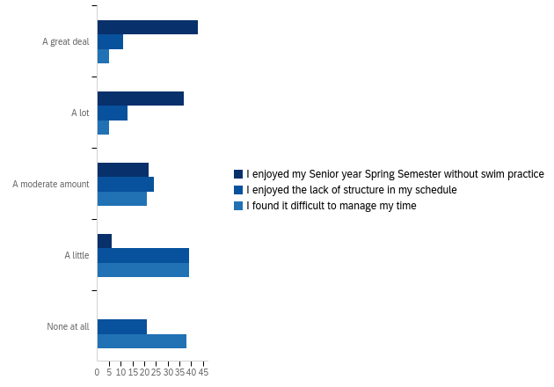

# | Field | Minimum | Maximum | Mean | Std Deviation | Variance | Count
1 | I enjoyed my Senior year Spring Semester without swim practice | 1.00 | 4.00 | 1.92 | 0.90 | 0.82 | 108
2 | I enjoyed the lack of structure in my schedule | 1.00 | 5.00 | 3.43 | 1.22 | 1.49 | 108
3 | I found it difficult to manage my time | 1.00 | 5.00 | 3.93 | 1.07 | 1.14 | 108

# | Question | A great deal |  | A lot |  | A moderate amount |  | A little |  | None at all |  | Total
1 | I enjoyed my Senior year Spring Semester without swim practice | 39.81% | 43 | 34.26% | 37 | 20.37% | 22 | 5.56% | 6 | 0.00% | 0 | 108
2 | I enjoyed the lack of structure in my schedule | 10.19% | 11 | 12.04% | 13 | 22.22% | 24 | 36.11% | 39 | 19.44% | 21 | 108
3 | I found it difficult to manage my time | 4.63% | 5 | 4.63% | 5 | 19.44% | 21 | 36.11% | 39 | 35.19% | 38 | 108

Q10 - How did you spend your new free time? Please select all that apply
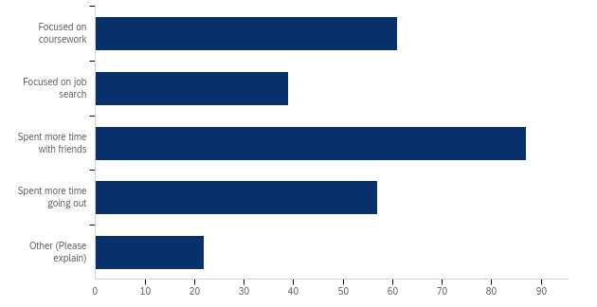

# | Answer | % | Count
1 | Focused on coursework | 22.93% | 61
2 | Focused on job search | 14.66% | 39
3 | Spent more time with friends | 32.71% | 87
4 | Spent more time going out | 21.43% | 57
5 | Other (Please explain) | 8.27% | 22
 | Total | 100% | 266
Other (Please explain)
I did not stop swimming my senior spring
Had more time for volunteer opportunities in the community
Spent time relaxing: sleeping, watching TV, reading for pleasure, etc.
After swim season, I started my full time profession while finishing my coursework.
Spent more time on myself
Spent a lot of time outside and doing things that were active besides swimming
Doing different forms of exercise
Engaging in new and different workouts
Worked more hours
Assisted with recruiting
working
Working out - going to the gym
New hobbies
Picked up new hobbies - biking
sleep
Grad school search
Studied for Nursing boards
I pursued and enjoyed other athletic, academic and social interests
Running/working out
I was student teaching full time so I had a new focus.
I was student teaching so I did not have free time!
Prepping for grad school

Q11 - Did you continue to swim in your Senior Year Spring semester?
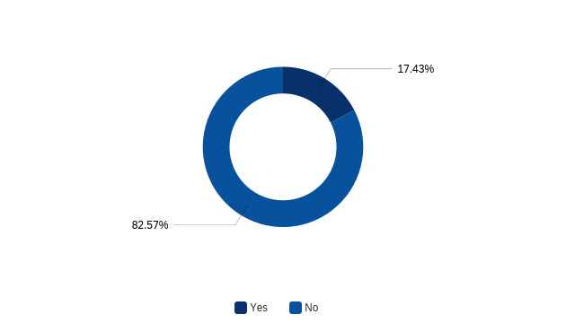

# | Field | Minimum | Maximum | Mean | Std Deviation | Variance | Count
1 | Did you continue to swim in your Senior Year Spring semester? | 1.00 | 2.00 | 1.83 | 0.38 | 0.14 | 109

# | Answer | % | Count
1 | Yes | 17.43% | 19
2 | No | 82.57% | 90
 | Total | 100% | 109

Q16 - Do you currently have any interest in exercise?
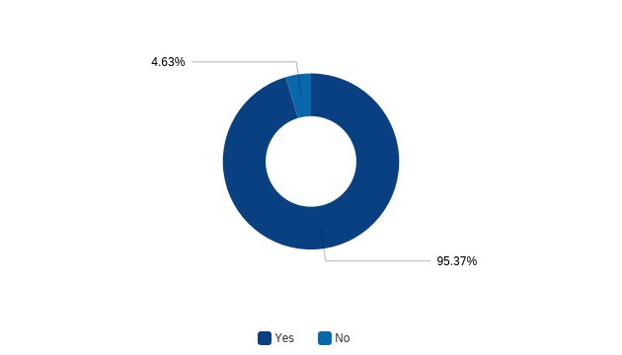

# | Field | Minimum | Maximum | Mean | Std Deviation | Variance | Count
1 | Do you currently have any interest in exercise? | 1.00 | 2.00 | 1.05 | 0.21 | 0.04 | 108

# | Answer | % | Count
1 | Yes | 95.37% | 103
2 | No | 4.63% | 5
 | Total | 100% | 108

Q17 - Do you have a structured weekly exercise schedule?
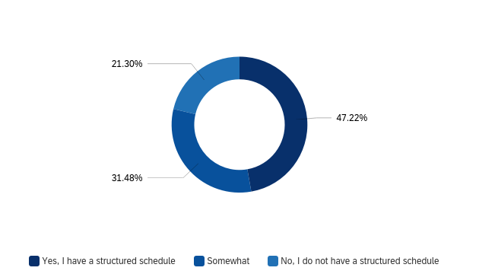

# | Field | Minimum | Maximum | Mean | Std Deviation | Variance | Count
1 | Do you have a structured weekly exercise schedule? | 1.00 | 3.00 | 1.74 | 0.79 | 0.62 | 108

# | Answer | % | Count
1 | Yes, I have a structured schedule | 47.22% | 51
2 | Somewhat | 31.48% | 34
3 | No, I do not have a structured schedule | 21.30% | 23
 | Total | 100% | 108

Q15 - When thinking about your attitudes towards exercise, please select how much you agree or disagree with the following statement.
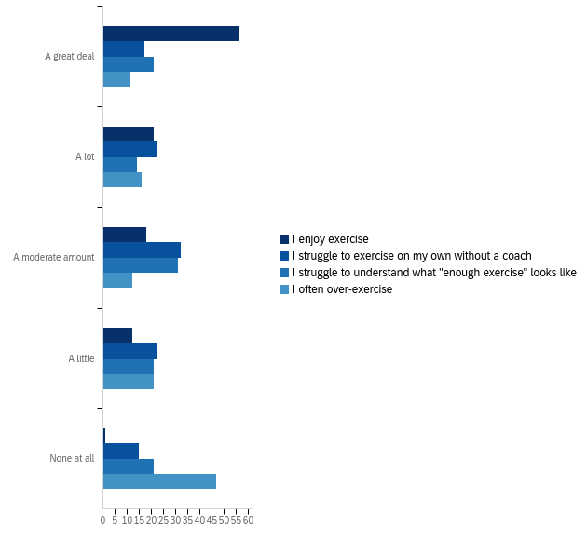

# | Field | Minimum | Maximum | Mean | Std Deviation | Variance | Count
1 | I enjoy exercise | 1.00 | 5.00 | 1.90 | 1.10 | 1.20 | 108
2 | I struggle to exercise on my own without a coach | 1.00 | 5.00 | 2.96 | 1.26 | 1.59 | 108
3 | I struggle to understand what “enough exercise” looks like | 1.00 | 5.00 | 3.06 | 1.37 | 1.88 | 108
4 | I often over-exercise | 1.00 | 5.00 | 3.72 | 1.41 | 2.00 | 107

# | Question | A great deal |  | A lot |  | A moderate amount |  | A little |  | None at all |  | Total
1 | I enjoy exercise | 51.85% | 56 | 19.44% | 21 | 16.67% | 18 | 11.11% | 12 | 0.93% | 1 | 108
2 | I struggle to exercise on my own without a coach | 15.74% | 17 | 20.37% | 22 | 29.63% | 32 | 20.37% | 22 | 13.89% | 15 | 108
3 | I struggle to understand what "enough exercise" looks like | 19.44% | 21 | 12.96% | 14 | 28.70% | 31 | 19.44% | 21 | 19.44% | 21 | 108
4 | I often over-exercise | 10.28% | 11 | 14.95% | 16 | 11.21% | 12 | 19.63% | 21 | 43.93% | 47 | 107

Q18 - Do you continue to swim, post-graduation?
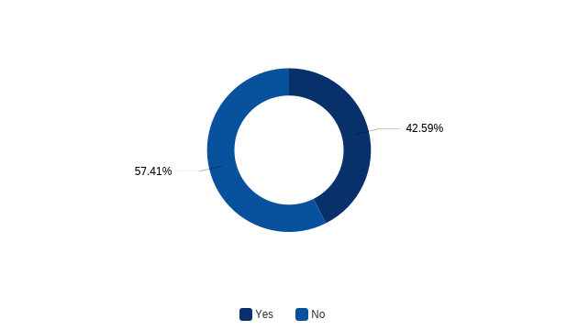

# | Field | Minimum | Maximum | Mean | Std Deviation | Variance | Count
1 | Do you continue to swim, post-graduation? | 1.00 | 2.00 | 1.57 | 0.49 | 0.24 | 108

# | Answer | % | Count
1 | Yes | 42.59% | 46
2 | No | 57.41% | 62
 | Total | 100% | 108

Q19 - How often do you swim currently?
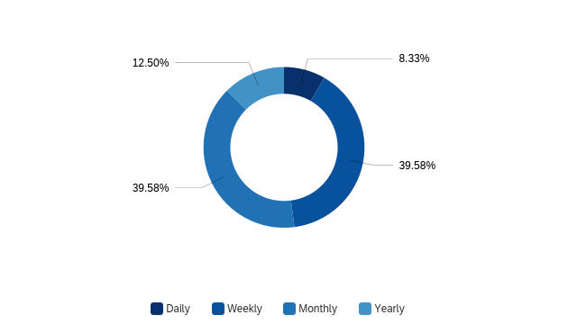

# | Field | Minimum | Maximum | Mean | Std Deviation | Variance | Count
1 | How often do you swim currently? | 1.00 | 4.00 | 2.56 | 0.81 | 0.66 | 48

# | Answer | % | Count
1 | Daily | 8.33% | 4
2 | Weekly | 39.58% | 19
3 | Monthly | 39.58% | 19
4 | Yearly | 12.50% | 6
 | Total | 100% | 48

Q20 - Do you currently participate in other sports?
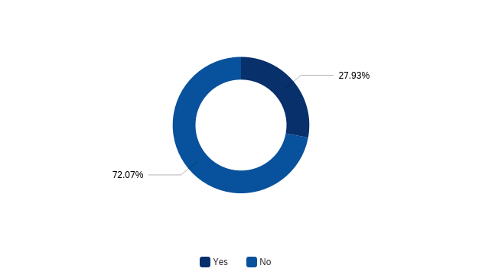

# | Field | Minimum | Maximum | Mean | Std Deviation | Variance | Count
1 | Do you currently participate in other sports? | 1.00 | 2.00 | 1.72 | 0.45 | 0.20 | 111

# | Answer | % | Count
1 | Yes | 27.93% | 31
2 | No | 72.07% | 80
 | Total | 100% | 111

Q21 - Do you participate in any of the following sports? Please select all that apply
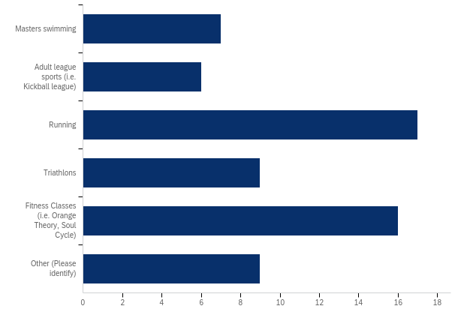
# | Answer | % | Count
1 | Masters swimming | 10.94% | 7
2 | Adult league sports (i.e. Kickball league) | 9.38% | 6
3 | Running | 26.56% | 17
4 | Triathlons | 14.06% | 9
5 | Fitness Classes (i.e. Orange Theory, Soul Cycle) | 25.00% | 16
6 | Other (Please identify) | 14.06% | 9
 | Total | 100% | 64

Other (Please identify)
Yoga
CrossFit, Obstacle course racing
Yoga
Peloton
Peloton
Aqua-bike
Climbing
Peloton cycling
CrossFit
Q22 - How frequently do you participate in these sports?
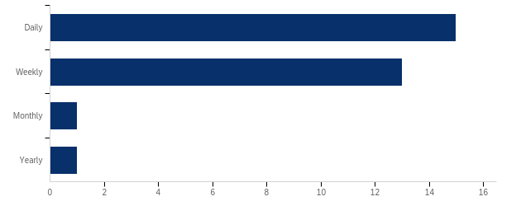

# | Field | Minimum | Maximum | Mean | Std Deviation | Variance | Count
1 | How frequently do you participate in these sports? | 1.00 | 4.00 | 1.60 | 0.71 | 0.51 | 30

# | Answer | % | Count
1 | Daily | 50.00% | 15
2 | Weekly | 43.33% | 13
3 | Monthly | 3.33% | 1
4 | Yearly | 3.33% | 1
 | Total | 100% | 30

Q23 - What are your motivations for exercising? (Please select all that apply)
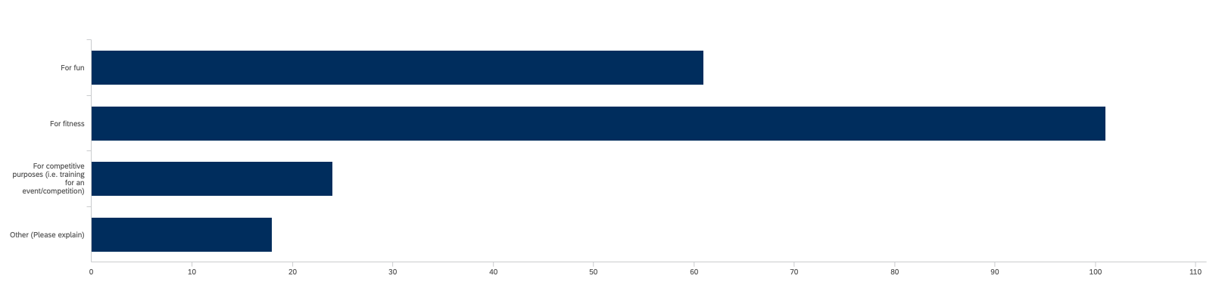

# | Answer | % | Count
1 | For fun | 29.90% | 61
2 | For fitness | 49.51% | 101
3 | For competitive purposes (i.e. training for an event/competition) | 11.76% | 24
4 | Other (Please explain) | 8.82% | 18
 | Total | 100% | 204
Other (Please explain)
Doing something for myself
Mental health and stability, as a release from the real world, as a social event
For endorphins/mood
Mental Health
To stay in shape/ lose weight
Mental well-being
mental release
Mental Health
Mental and physical health
All of the above
de-stressing
mental health
helps with anxiety
A combo of all three!
For health reasons
Social life
Exercising with friends and family
Having children makes it difficult to exercise alone as I focus on keeping them active.

Q24 - Are you currently employed?
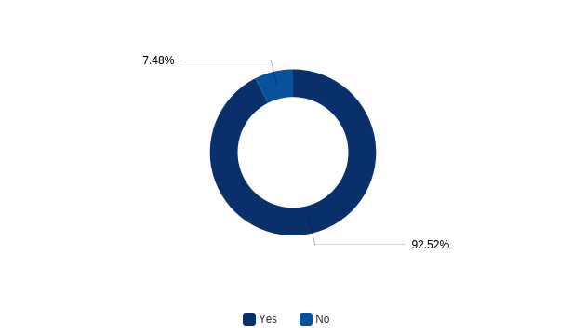

# | Field | Minimum | Maximum | Mean | Std Deviation | Variance | Count
1 | Are you currently employed? | 1.00 | 2.00 | 1.07 | 0.26 | 0.07 | 107

# | Answer | % | Count
1 | Yes | 92.52% | 99
2 | No | 7.48% | 8
 | Total | 100% | 107

Q27 - Do you think your years of swimming has helped your career?
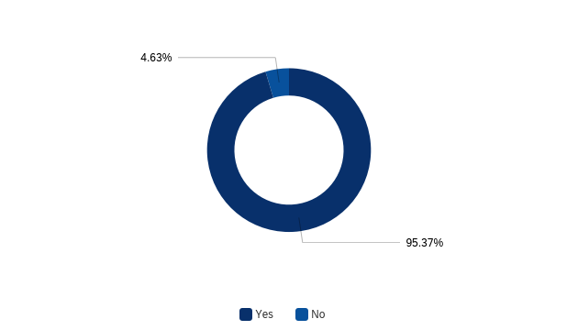

# | Field | Minimum | Maximum | Mean | Std Deviation | Variance | Count
1 | Do you think your years of swimming has helped your career? | 1.00 | 2.00 | 1.05 | 0.21 | 0.04 | 108

# | Answer | % | Count
1 | Yes | 95.37% | 103
2 | No | 4.63% | 5
 | Total | 100% | 108

Q29 - What is your relationship like with swimming?

# | Field | Minimum | Maximum | Mean | Std Deviation | Variance | Count
1 | What is your relationship like with swimming? | 1.00 | 5.00 | 2.03 | 0.92 | 0.85 | 107

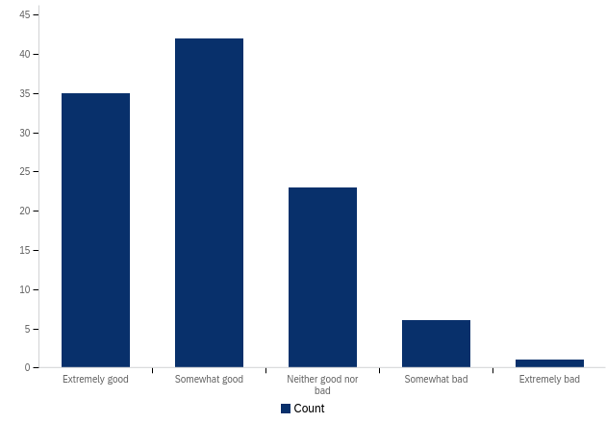

Q30 - Do you miss swimming?
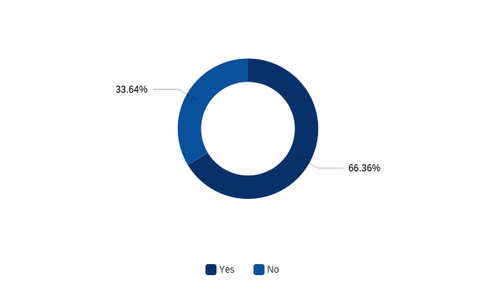

# | Field | Minimum | Maximum | Mean | Std Deviation | Variance | Count
1 | Do you miss swimming? | 1.00 | 2.00 | 1.34 | 0.47 | 0.22 | 107

# | Answer | % | Count
1 | Yes | 66.36% | 71
2 | No | 33.64% | 36
 | Total | 100% | 107

